Data Cleaning & Essential Functions Assignment – Rakesh Ponnoju
Drive Link -
1. What is data cleaning, and why is it important in data analysis?
Data cleaning is the process of identifying and correcting errors, missing values, duplicate records, and inconsistent formatting in a dataset.
Importance of Data Cleaning:
- Improves data accuracy
- Helps in better decision-making
- Removes duplicate or incorrect data
- Makes analysis reliable
- Saves time during reporting and visualization

What are the potential consequences of analyzing unclean or messy data?
If unclean data is analyzed:
- Wrong conclusions may be generated
- Reports become inaccurate
- Duplicate values affect calculations
- Missing data may distort analysis
- Business decisions can become unreliable

Explain the common steps involved in cleaning and organizing data.
Common Steps:
- Remove duplicate records
- Correct spelling mistakes
- Fill or remove missing values
- Remove extra spaces using TRIM
- Standardize formatting
- Validate data entries
- Sort and filter the dataset
- Check formulas and calculations
2. How would you sort the dataset first by "Department" (A–Z) and then by "Salary" (Largest to Smallest)?
Employee | Department | Salary
Pranav | HR | 5000
Sonu | IT | 4000
Rahul | IT | 2500
Steps:
- Select the complete dataset including headings
- Go to the Data tab in Excel
- Click on Sort
- In the “Sort by” option:
  - Select Department
  - Order → A to Z
- Click Add Level
- In “Then by”:
  - Select Salary
  - Order → Largest to Smallest
- Click OK
3. Explain the use of text functions such as TRIM, LEFT, RIGHT, MID, and CONCAT in data cleaning.
Uses in Data Cleaning:
- Standardizing text
- Extracting important information
- Combining multiple columns
- Removing unwanted spaces

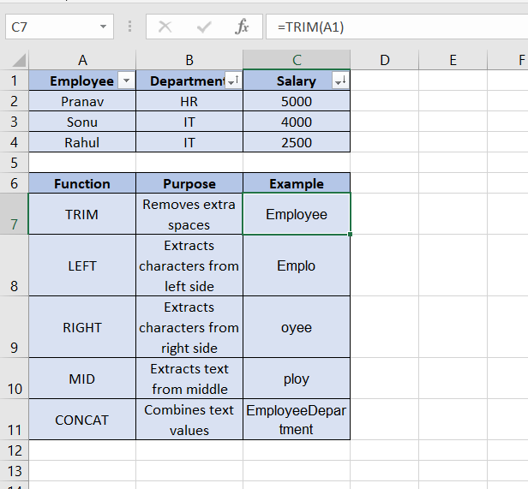

4. What is the role of date functions like TODAY in managing datasets?
The TODAY() function returns the current date automatically.
Roles of TODAY():
- Tracks deadlines
- Calculates remaining days
- Monitors attendance
- Creates dynamic reports
- Updates date automatically every day
Example:
=TODAY()
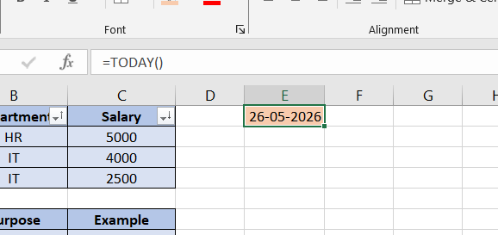

5. Apply Data Validation to Restrict Quantity Values (1 to 10)

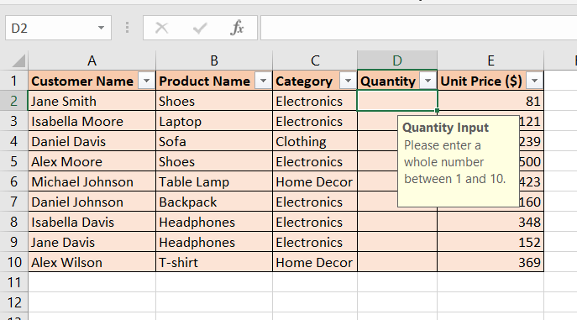

6. Understand and Apply LEFT, RIGHT, MID, and LEN
Function | Purpose
LEFT | Extract characters from left side
RIGHT | Extract characters from right side
MID | Extract characters from middle
LEN | Count total characters

      - Extract first 5 characters from "ExcelTipsAreGreat"
      - Extract last 4 characters from "DataAnalysis.xlsx"
      - Extract the substring "Tips" –
      - Count total characters in "Hello World!"
      - Extract middle 6 characters from "12345-67890-ABCDE"
ExcelTipsAreGreat | Excel
DataAnalysis.xlsx | xlsx
ExcelTipsAreGreat | Tips
Hello World! | 12
12345-67890-ABCDE | 67890-

7. Understand how to combine text using CONCAT, TEXTJOIN, and the & operator
a) Use CONCAT to combine "Hello" and "World" with a space in between
Hello World
Hello | World | Hello World
=CONCAT("Hello"," ","World") & =CONCAT(A19," ",B19)
b) Combine "Apple", "Banana", and "Cherry" into a single string separated by commas using TEXTJOIN
Apple
Banana | Apple, Banana, Cherry
Cherry
=TEXTJOIN(", ",TRUE,A20:A22)
c) Use the & operator to create the string "2025: Excel Functions"
Formula:
="2025"&": "&"Excel Functions"
Output:
2025: Excel Functions
d) Create a comma-separated list from the range A1:A5 using TEXTJOIN
Formula:
=TEXTJOIN(", ",TRUE,A1:A5)
Explanation:
- Combines all values from cells A1 to A5
- Adds commas between them
- Ignores empty cells because TRUE is used

e) Combine first names in column A with last names in column B to create full names in column C
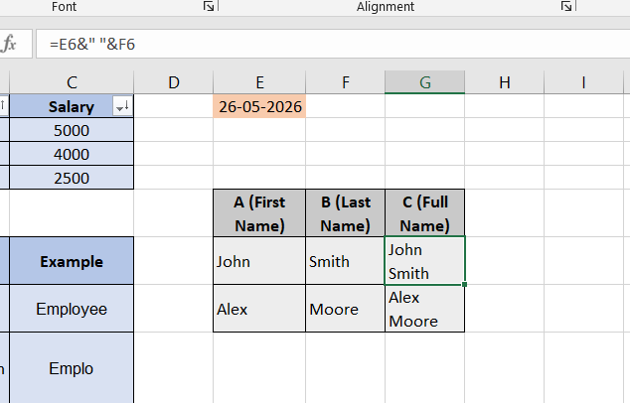

- Understanding TODAY() and NOW()

a) Difference between TODAY() and NOW()
Function | Purpose
TODAY() | Returns current date only
NOW() | Returns current date and current time

Examples

TODAY()
=TODAY()

Example Output:
26-05-2026

NOW()
=NOW()

Example Output:
26-05-2026 16:56

When to Use
Function | Usage Example
TODAY() | Attendance, deadlines, age calculation
NOW() | Timestamp logging, real-time tracking
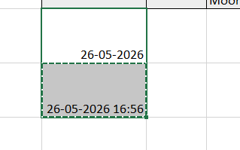

c) Formula using NOW() to display current date and time in format MM/DD/YYYY HH:MM AM/PM
Formula:
=TEXT(NOW(),"MM/DD/YYYY HH:MM AM/PM"
d) What happens when worksheet is reopened the next day?
If a cell contains:
=TODAY()
The value updates automatically to the new current date whenever the workbook is reopened or recalculated.
Example:
- Today → 26-05-2026
- Tomorrow after reopening → 27-05-2026

e) Keyboard shortcut to insert static current date
Shortcut:
Ctrl + ;
Explanation:
- Inserts today’s date as a fixed value
- Does not change automatically later

